Big Data Term Project 2 Report

Here firstly will be the list of consistent and inconsistent brands or product id based on trust and ratings.

This is according to brand name and based on the rating and the sentiment score and trust

Top 10 consistent products:

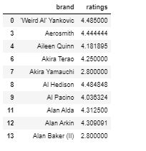

Top 10 inconsistent products

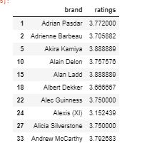

The product consistent to inconsistent rating:

